History of the German Spitz

The Spitz is the oldest breed of dog in Central Europe and served as the progenitor of many European breeds. Well preserved specimens of Stone Age “Peat Dogs” known as the “Torfhund” (Canis familiaris palustris Rüthimeyer) dating back 6,000 years have been found in the Netherlands, Germany, Denmark, England and Ireland that closely resemble modern European Spitz dogs.

The term “Spitz” is derived from the Old Dutch language and literally translates as “pointed peaks,” referring explicitly to the image of snowcapped mountain peaks that span the northern European and sub-Arctic regions. The pointed ears and wedge shaped muzzle of the Spitz looked like breeds triangular and fuzzy appearance of the snow-swept peaks. Even now, the German refer to them as “tips” or “peaks”.

During the Viking era, circa 800-1100 AD, Norsemen from Denmark, Sweden and Norway built superior ships and engraved their mark in history as ravenous explorers and warriors. Vikings are famous for conquests of coastal and river towns throughout Europe, but they also established colonies, engaged in trade and fortified the military and naval strength of their regions. They brought the basic elements of their culture with them, most significantly introducing a small furry dog with a curly tail and foxy face to the heart of continental Europe. There is a tale from some thousand years ago of a Viking ship that foundered off the coast of Friesland (the Netherlands). The crew perished except for one man saved by a local fisherman in his cog (the style of fishing boat) with his dog. The two men and the little white dog were caught in the storm and forced southward until they eventually managed to land on a small area of higher ground. They built a small chapel at the site to give thanks for their deliverance. This is the place where Amsterdam slowly grew to become an important town. The Great Seal of Amsterdam illustrates this event, and you can see the little dog peering over the side of the boat. This stamp is now in the library of Yale University, New Haven, CT. In 1790 an unknown writer in the Netherlands wrote the first book about the large white Keeshond – “Cases of a Keeshond in the Netherlands”.
“
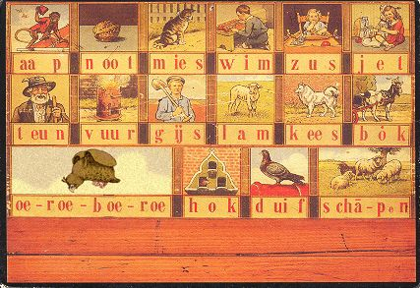
The white keeshond also appeared on the reading board Stamp of the City of Amsterdam

The German Spitz was primarily a watchdog, selected for lack of hunting drive, and for territorial behavior, so that he does not leave the territory assigned to him and if necessary also defends it. The lack of hunting behavior of the German top played an important role in the Middle Ages. At that time, the nobles attached particular importance to preserving their game. The hunting-capable dogs of the farmers were usually destroyed. In many cases, the feudal lords decided to give the smaller peasants and cows a German Spitz, because he did not hunt large animals, only vermin. A good watchdog must be willing to submit to his master, of course, but in the absence of his master, he can make independent decisions in his own interest. This led to the Spitz being attached to his home, but also self-confident and sometimes obstinate. Intruders are immediately reported loudly and usually held until the dog owner arrives and decides how to proceed. From: Economic Encyclopedia, JG Krünitz (published: 1773-1858) In earlier times burglars and thieves on the farms were by no means just humans, but also rats, mice, weasels, fox as well as stray dogs and cats. Therefore, the Spitz is not fundamentally friendly to other dogs and uninvited strangers. The upright ears and bushy tail curled high on the back of the Spitz usually signals to foreign dogs and people that they are dealing with a self-confident dominant dog.

Old postcards

While the color of the small spitz had no special meaning, the gross spitz had different areas of distribution and characteristics depending on the color, not because certain properties are genetically linked to the color, but because of the different uses of the dogs. The white gross Spitz was mainly in northern and central Germany. He was a typical guardian of the farm and was used for herding sheep (Pommer'scher Hütespitz). The white color is of particular importance to a herding dog, because it is so easy to distinguish it from the wolf over long distances and in the dark. The black spitz were especially widespread in the southern German wine-growing regions. During the day they guarded the yard and at night they were sent to the vineyards. This is why the black spitz was once often referred to as vineyard or vine spitz and guarded the vineyards from vermin and animals such as the wild boar. A large dog was consider to be at a disadvantage because of its own mass compared to a smaller more nimble and agile dog that could move quickly through between the vines. The thick black coat provided protection as well as hid him from his prey.
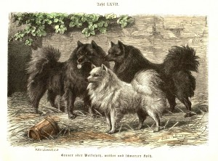
The early black and white Spitz
The brown Spitz was also common in southern Germany. He was considered extinct for a long time. However, in 2011 the first brown Großspitz, was bred by backcrossing from the black spitz.
These days the German Spitz is primarily a companion and watchdog, and its vermin control restricted to activities such as Barn Hunt. The smaller sizes are now more prevalent, due to two World Wars and the resulting urbanization.

Registration and Separation into Colors and Sizes

The Association for German Lace was founded in 1899. Only the colors white, black and wolf-grey were recognized. Although the white spitz were usually only paired with each other, they crossed every few generations to a black spitz to strengthen the pigmentation.
In 1906, all colors were allowed for small spitz, but not for large spitz.
In 1958, colors for the small spitz were limited to white, black, brown, orange and other colors. The big spitz were still only registered as the wolf-grey (registered in other countries as “the Keeshond”, white, black and brown.
From 1958, colors were separated for breed exhibition, with one exception in that black is paired with brown.
In 1959, the sizes were further divided into four different sizes: Zwergspitz (Pomeranian), Kleinspitz (toy), Mittelspitz (miniature) and Großspitz (large or giant).
In 1969, the size variant of the Mittelspitz was added to the FCI and German Standard.
In 1974, the Zwergspitz / Pomeranian (registered in other countries as a separate breed, but crossed with klein spitz in Europe) was included in the FCI breed standard, with the same colors as the Mittelspitz. The "Different color" was recognized in 1990.
In the United Kingdom, only the klein and mittelspitz sizes are recognized.

